
Wutan New England
Martial Arts Research and Development Center

Registration and Contract

First Name: ___________________________ Last Name: _______________________________
Age: _____ Date of Birth: ___/___/_____
To Be Completed By Student and/Or Parent/Guardian – If Under Age 21
Student and/or Guardian Name:
First Name: ___________________________ Last Name: _______________________________
E-mail :__________________________________________________
Cellphone:___________________________ Home/Work phone:_________________________
Address: ________________________________________ City: __________________________
State and Zip code:______________________________
Uniform Size
T-Shirt size: _____ Kung Pant size (see chart below): ______
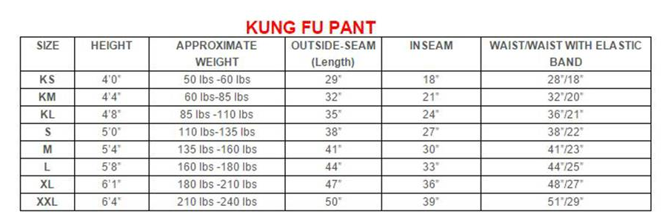
Waiver and Release
I do hereby agree to participate in the Wutan New England LLC (referred to as “Company”) Activities, located at 359 Littleton Rd, Westford, MA 01886 or any other eventual location. The responsible party must read the entire contract before signing.
I recognize the risks of injury that are common to any performing martial arts program that my child or I participate in, and I do hereby waive and release the Company from and against any and all claims, actions, causes of action, damages, costs, liabilities, expense of judgments, including attorney’s fees and court costs, that arise out of my participation in this program. I hereby execute this Waiver and Release form permitting my minor child and / or myself to participate in the Company’s program.
I understand that the classes are based on a twelve-month calendar year and that tuition for the (years) school session is based on a twelve-month calendar year. Students will average eight or more classes per month / per calendar year. I understand that two installments for new enrollments are due at registration: annual registration and first month tuition. Students renewing will pay their annual registration fee each year. Tuition and testing fees (if eligible) are due and must be paid on or before the 1st of each month, regardless of Student’s absence, major holidays, and / or school holidays. I understand that I will not receive a courtesy bill reminder, and that tuition not received by the first of each month will assess a late charge, starting at $15.00. Returned checks will result in a $25.00 penalty fee. When eligible students will receive a bill for testing fees on. Be advised that it is the student and / or Guardian’s responsibility to make sure payment is received on time. Delinquent accounts will be turned over to a collection agency. All fees are subject to an annual increase due to the cost of living.
I understand that Registration fees, tuition, equipment, camps, birthday parties, testing fees and private lessons are non-refundable. I understand that if I wish to terminate membership, I will provide the Company a notice on or before the 25th of the current billing cycle month. There are no pro-rations or refunds upon registration enrollment excluding the following exceptions. When a new student enrolls during their first month and wishes to start immediately with fewer than eight classes left in a month. For that month only a pro-ration will be allowed and charged $20.00 per class. This does not apply during major holidays, school holidays, and / or when the School is closed.
Competition and/or Performance Uniforms, equipment, camps, testing fees, private lessons, etc. are all additional costs and are not included in with tuition or registration. It is the Parent and / or Guardians responsibility to bring the student into the building and to pick them up. Siblings must always be monitored and quite or will be asked to leave. We do ask that students come to class dressed and remain seated or line up prior to their scheduled class. Parents and family members can stay in the waiting area o in the car. Also, can request authorization to watch classes anytime but must be quiet and not disturb the students or staff.
By signing below indicates that you have read the Waiver and Release guidelines, terms and conditions, and regulations on this contract and fully understand the contents. This contract will remain on file in the School office unless the terms and conditions change. At that time a new contract will be executed.
I hereby grant my permission to use my or my child’s photograph publicly in print publications, online publications, presentations, websites and social media with no royalty, fee, or other compensation payable to me by reason of such use.
I have executed this Waiver and Release this ______ day of _______, 20______.

___________________________________________________
Signature of Student or Parent/Guardian if under the age of 21
Wutan New England
Martial Arts Research and Development Center
PRE-EXERCISE - MEDICAL SCREENING TOOL
Please circle response
1. Has your doctor ever told you that you have a heart condition or have you ever suffered a stroke? | Yes | No
2. Do you experience unexplained pains in your chest at rest or during physical activity/exercise? | Yes | No
3. Do you ever feel faint or have spells of dizziness during physical activity/exercise that causes you to lose balance? | Yes | No
4. Have you had an asthma attack requiring immediate medical attention at any time over the last 12 months? | Yes | No
5. If you have diabetes (type I or type II) have you had trouble controlling your blood glucose in the last 3 months? | Yes | No
6. Do you have any diagnosed muscle, bone or joint problems that you have been told could be made worse by participating in physical activity/exercise? | Yes | No
7. Do you have any other medical condition(s) that may make it dangerous for you to participate in physical activity/exercise? | Yes | No
8. Do you have a Family history of heart disease (eg: stroke, heart attack) | Yes | No
9. Do you smoke cigarettes on a daily or weekly basis or have you quit smoking in the last 6 months? | Yes | No
10. Have you been told that you have high blood pressure? | Yes | No
11. Have you been told that you have high cholesterol? | Yes | No
12. Have you been told that you have high blood sugar? | Yes | No
13. Have you spent time in hospital (including day admission) for any medical condition/illness/injury during the last 12 months? | Yes | No
14. Are you currently taking a prescribed medication(s) for any medical conditions(s)? | Yes | No
15. Are you pregnant or have you given birth within the last 12 months? | Yes | No
16. Do you have any muscle, bone or joint pain or soreness that is made worse by particular types of activity? | Yes | No
17. Are you currently taking any drugs that may impair your reaction time or judgement | Yes | No
18. Please list any physical or medical limitations we should be aware of:
Some medical conditions may require the provision of a medical certificate prior to training. I believe that to the best of my knowledge, all of the information I have supplied within this tool is correct. I recognize the instructor is not able to provide me with medical advice regarding my physical fitness and that the information I have provided will be used as a guideline to the limitations of my ability to exercise and participate in martial arts training.
Signature:___________________________________________Date: _____________
Wutan New England
Martial Arts Research and Development Center

Emergency Medical Release
First Name: ___________________________ Last Name: _______________________________
Age: _____ Date of Birth: ___/___/_____
Street Address: ____________________________City: _________State: _______Zip_________

Emergency Information

Father’s Name: _________________ Home Ph#________________ Cell#_________________
Mother’s Name: ________________ Home Ph#________________ Cell#_________________

In an Emergency when parent/Guardian cannot be reached or is not applicable, please contact the following:
Name: ___________________ Home Ph#__________________ Cell#___________________
Name: ___________________ Home Ph#__________________ Cell#___________________

MEDICAL INFORMATION

Allergies: __________________________________________________ Epi-Pen (Y/N) _______
Other Medical Conditions: _______________________________________________________
Physician: ___________________________________ Contact #: ________________________
List of Medication currently taken__________________________________________________

Medical/Hospital Insurance Company: ______________________________________________
Group/Plan #: ____________________________________ Phone #: _____________________
Policy Holder’s Name: ______________________________________

THIS AUTORIZATION FOR EMERGENCY MEDICAL TREATMENT MUST BE COMPLETED BY THE END OF THE REGISTRATION PERIOD IN ORDER FOR THE PARTICIPANT TO PARTICIPATE IN ACTIVITIES. EMERGENCY TREATMENT WILL BE BASED UPON INFORMATION PROVIDED HEREIN.

Student’s Signature _________________________________ Date____________________

Parent/Guardian Signature ____________________________Date______________________

